**Velammal College of Engineering and Technology, Madurai**

**An Autonomous Institution**

**Department of Computer Science and Engineering**

**21CS205 Object oriented programming lab**

**Exercise** 11

Data Base Connectivity

Data Base

1. Set up Data Base

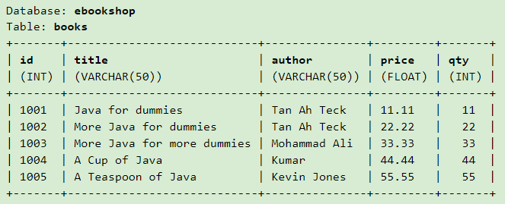

2. Functions

1. SELECT * FROM books
2. SELECT title, author, price, qty FROM books WHERE author = 'Tan Ah Teck'
3. Increase the price by 50% for "A Cup of Java".
4. Set the qty to 0 for "A Teaspoon of Java".
5. Delete all books with id = 8001;
6. insert: (8001, 'Java ABC', 'Kevin Jones', 15.55, 55) and (8002, 'Java XYZ', 'Kevin Jones', 25.55, 55);

Front Page

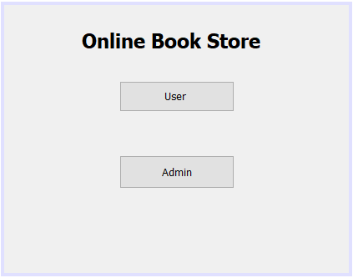

User Page

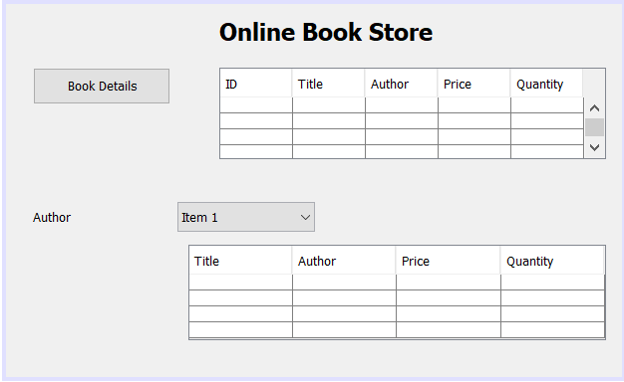

Admin Page

